CNEXT Series CNC

**CNEXT-Woodworking Drilling and Cutting Software Manual**



Guangzhou Forwin Innovative Technology Co.,LTD.

Vx.x

### directory

directory 2

1 user interface 1

1.1 Status bar 1

1.1.1 Coordinate column 2

1.1.2 Manual movement 3

1.1.3 Control columns 4

1.1.4 Setting the workpiece zero point 5

1.1.5 Setting parameters 6

1.2 Machining trajectories 8

1.2.1 Count Zero: 8

1.2.2 Breakpoint runs: 9

1.2.3 Selection of rows for processing: 10

1.3 Tool magazine 11

1.4CAM 13

1.4.1 Parameter setting steps: 13

1.4.2 Importing DXF 16

1.4.3 Generation programme 17

1.4.4 Saving loads 18

1.5 I/O Status 19

1.5.1 Modifying pins 19

1.5.2 Modifying polarity 20

1.6 Log messages 20

1.7 System set 21

1.7.1 Remote control 22

1.7.2 Software registration 22

1.7.3 Operational authority 23

1.7.4 Software updates 23

1.7.5 Generating backups 24

1.7.6 Soft keyboard 24

1.7.7 System parameters 25

1.7.8 Servo parameters 27

1.8 Document management 28

2 Software Debugging 29

2.1 Communication configuration 29

2.1.1 Communication parameters 29

2.1.2 Connection order 30

2.1.3 Driver Enablement 30

2.1.4 Debugging axis parameters 31

2.2 Setting the pulse equivalent 31

2.2.1 Determining axis orientation 31

2.2.3 Determining machine travel 32

2.2.4 Debugging IO 32

2.2.5 Setting process parameters 32

2.2.6 Setting the workpiece zero point 32

3 Quick start 33

3.1 Establishment of communications 33

3.2 Loading procedures 33

3.3 Run processing 33

# 

# 1 **user interface**

CNEXT CNC system interface function partition is shown in Figure 1-1. Among them, the display window mainly includes: tool magazine, common parameters, machining trajectory, CAM, IO status, log information, system settings, file management.

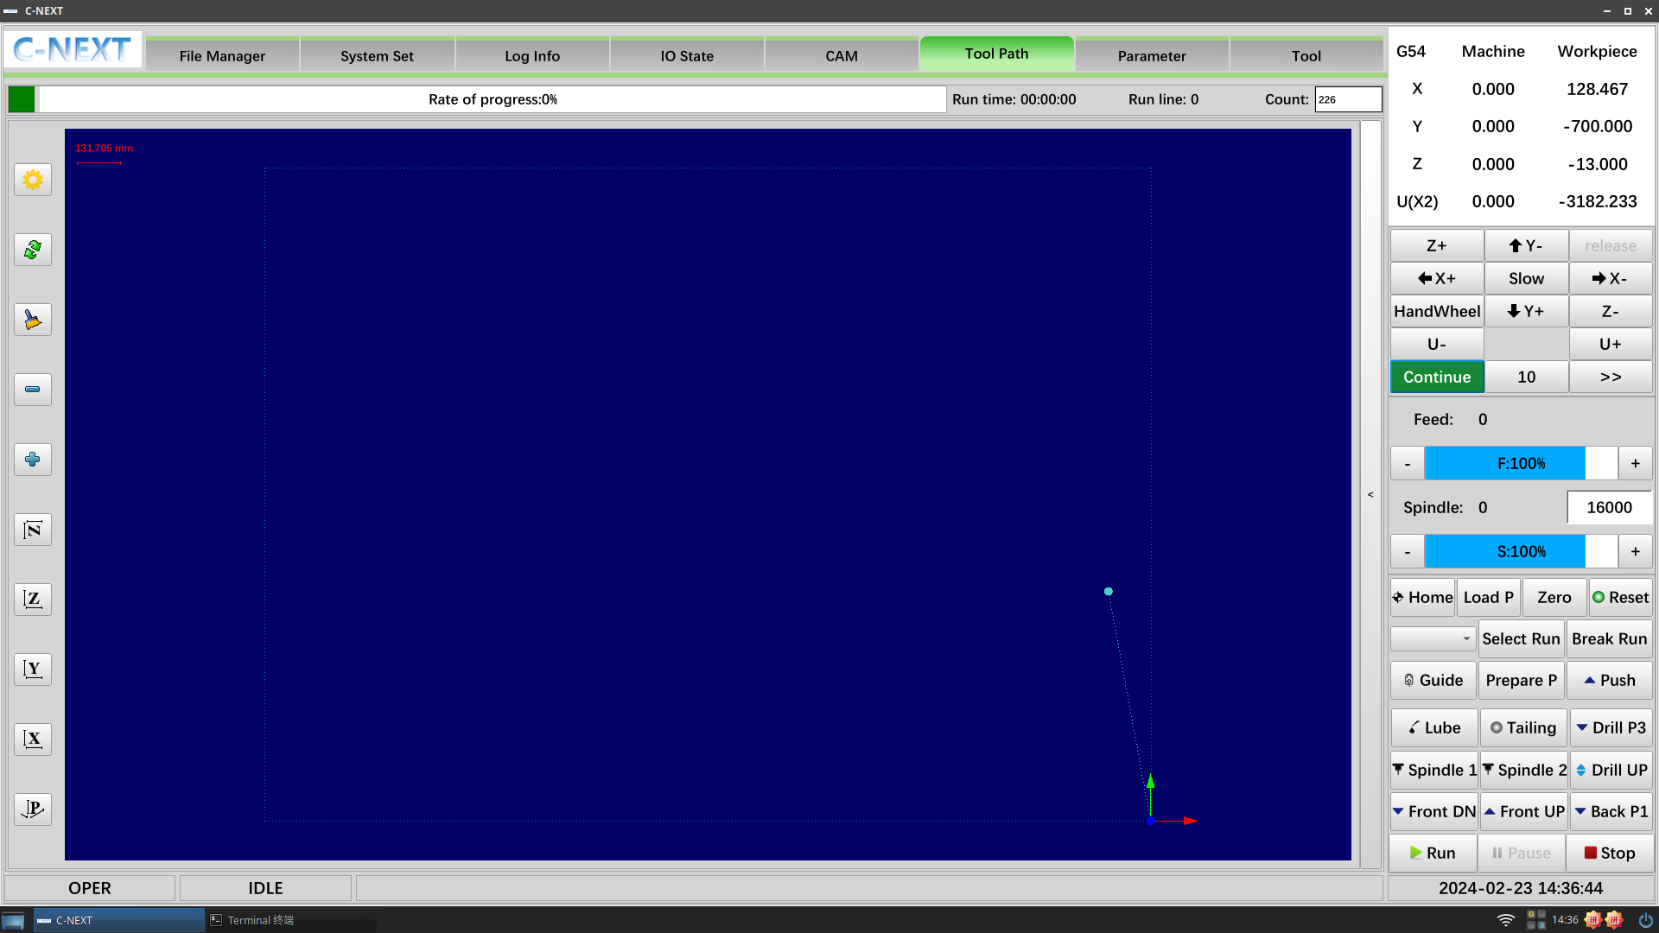

(Figure 1-1, Operation Interface)

## 1.1 Status bar

The status bar mainly displays the mode, status, and information, as shown in Figure 1-2.



(Figure 1-2, status bar)

<State>: running, suspended, idle three states, as shown in Figure 1-3. (a);

 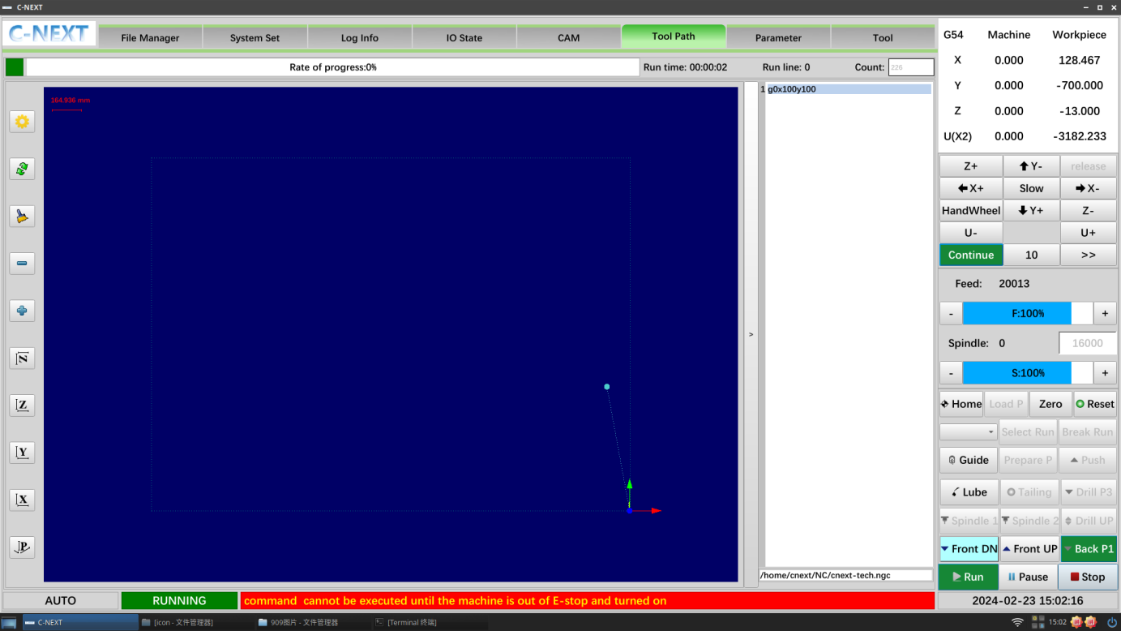 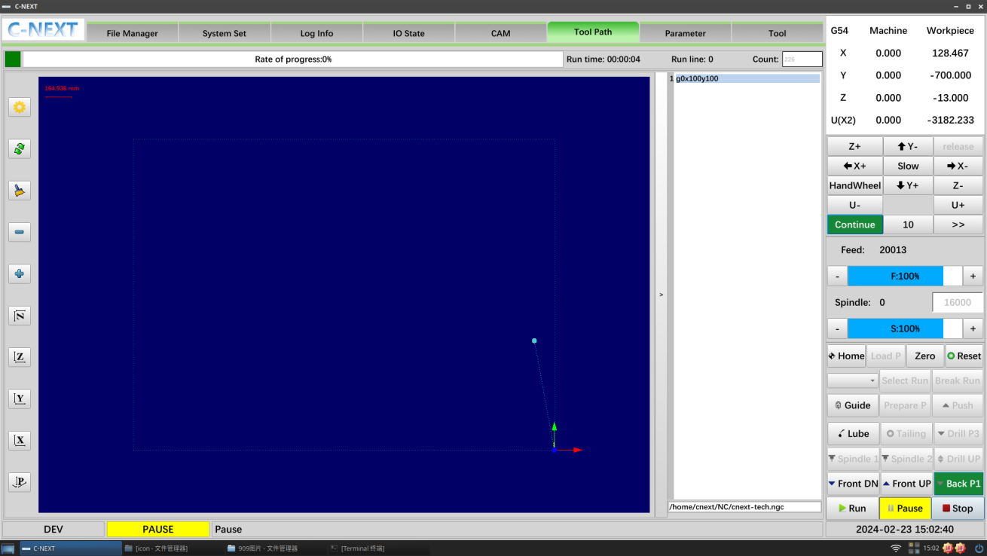

(Figures 1-3)

<Info>: Displays real-time operations, warnings, error messages, etc;

### 1.1.1 Coordinate column

* **Mechine:** the values displayed for each axis are values calculated using the mechanical zero point as a reference point. Because the mechanical zero point is uniquely fixed, only axis movement can change the machine coordinates;
* **Workpiece :** the values displayed for each axis are those calculated using the current system zero offset as a reference point. Even if there is no movement in the machine axes and the zero offset is changed, the values of the three axes will change accordingly;



(Figure 1-3, Coordinate column)

### 1.1.2 Manual movement

**Manual column is mainly to control the feed movement of each axis, mainly continuous, handwheel, incremental, the percentage of the multiplier can be controlled by the speed of the current feed multiplier display**

**As shown in Figure 1-3:**



**(Figures 1-3)**

* **Continuous feed:**When switching to manual window, the system defaults to manual continuous feed mode, click <Continue> button in the table control bar, you can make the table move continuously along the selected direction of the selected axis.
* **Handwheel feed** :Under the handwheel feed, the operator can make micro-movement by rotating the hand crank pulse generator on the handwheel. The minimum distance that the tool moves when the hand pulse generator rotates by one scale (can be set by parameter), the system default "×1, ×10, ×100" corresponds to the movement amount of "0.001, 0.01, 0.1" (unit in mm) respectively. Handwheel feed is mostly used for parts machining. The handwheel feed is mostly used for the adjustment of parts processing and the setting of the zero point of the processing workpiece.

Fast: fast operation in manual mode

Slow: slow operation in manual mode

* **Incremental Mode**: When the button is selected, the axis movement will go the current incremental value by the value entered;

### 1.1.3 Control columns

**Power on to return to zero, set the zero point of the workpiece, break the line as well as select the line function, debug the manual output, etc., start and stop of the running programme, handwheel operation 1-4;**



* **Run:** CNC back to fixed point, send gantry material signal, programme run;
* **Pause:** The procedure is suspended;
* **Stop**: The procedure is stopped;
* **Guide: Handwheel guided operation;**
* **Reset**: when the icon is red,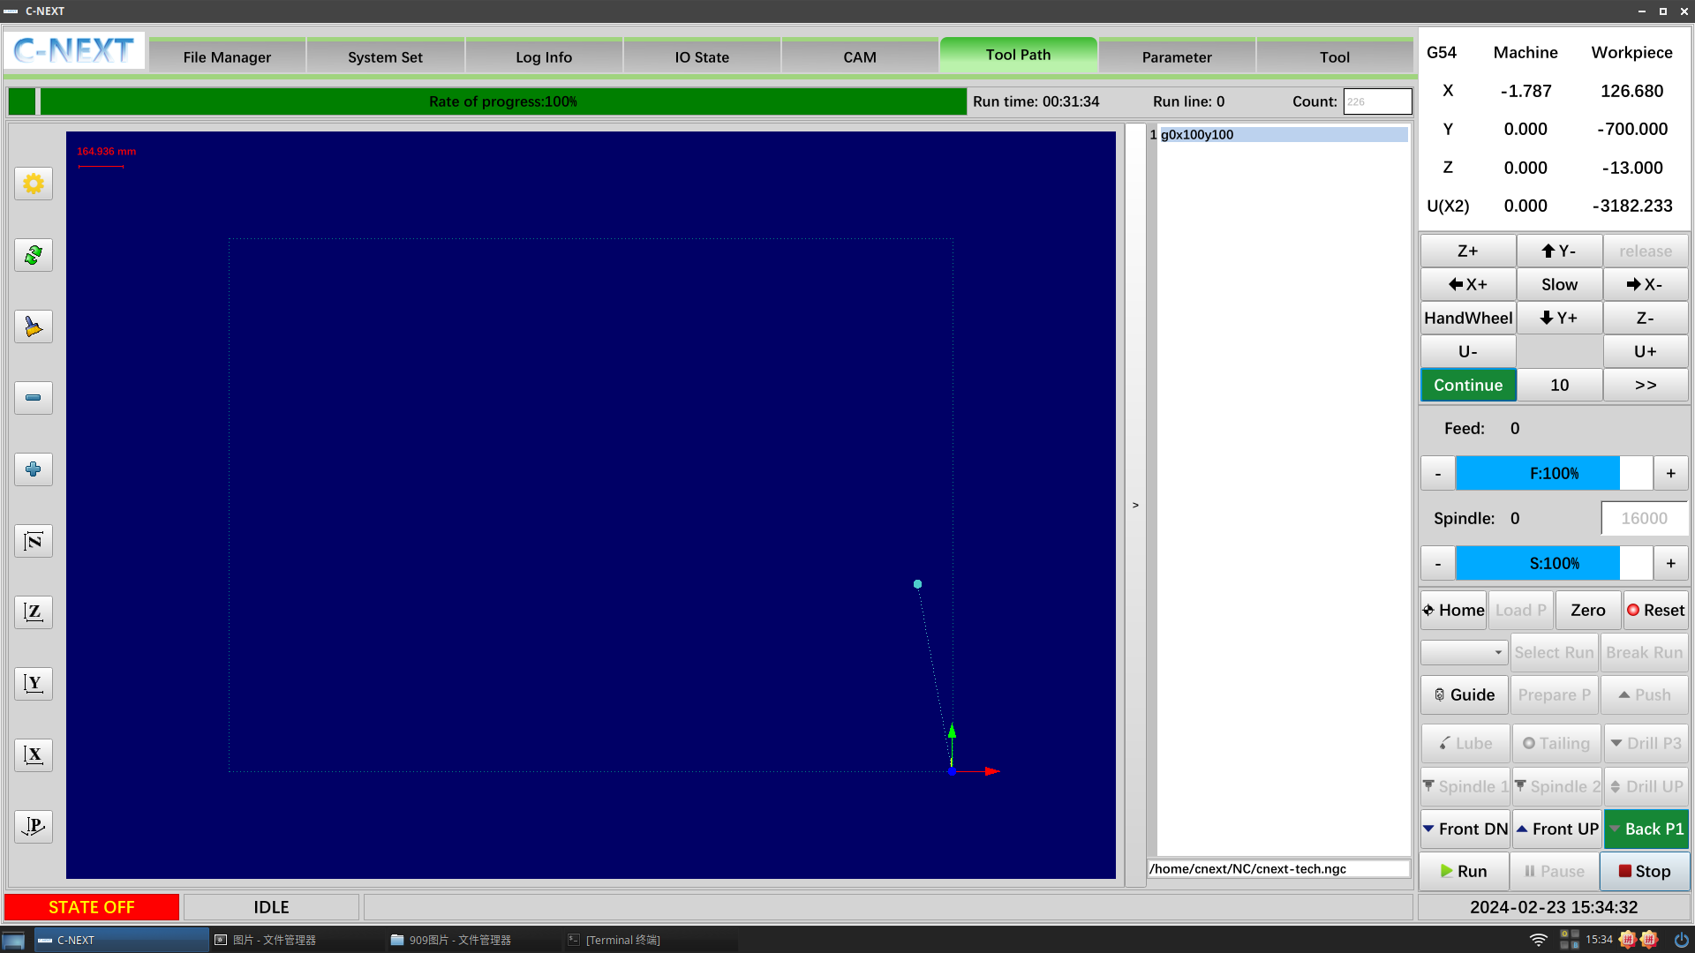 Click reset to enable the servo and reset the software status; when the icon is red,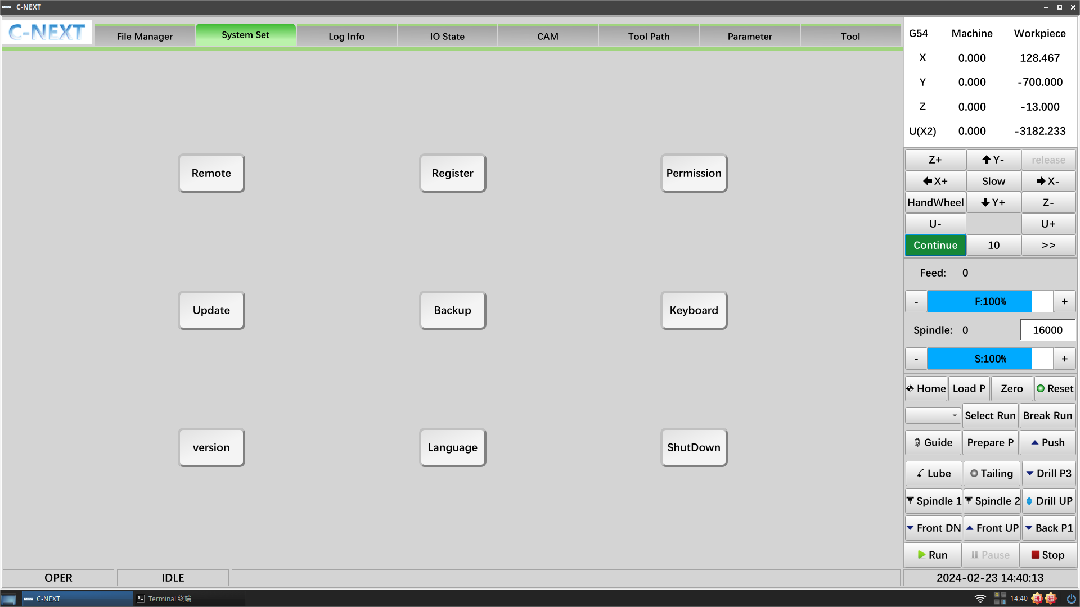 indicates that the system has sent the enable signal and the servo is enabled; when the drawing is green, the servo is already enabled; when the icon is red, indicates that the system has sent the enable signal and the servo is enabled; when the drawing is green, the servo is already enabled.
* **Load P:** back to the position of the loading point, convenient for debugging and setting the zero point of the workpiece;
* **Select Run: Machining Trajectory page details;**
* **Break Run: Machining trajectory page details;**

### 1.1.4 Setting the workpiece zero point

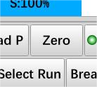

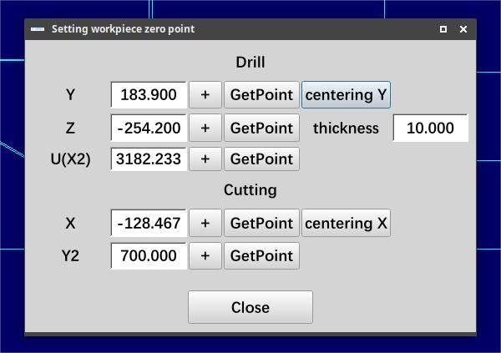

(Figure 1-7, Workpiece Zero)

**Setting the workpiece zero point method**:

1) Just move directly to the workpiece position to take the point;

***(Thickness: just fill in according to the actual thickness of the plate, and the value filled in corresponds to the conversion to Z above the workpiece coordinates)***

### 1.1.5 Setting parameters

* **Delay parameter \ Anti-collision parameter:**

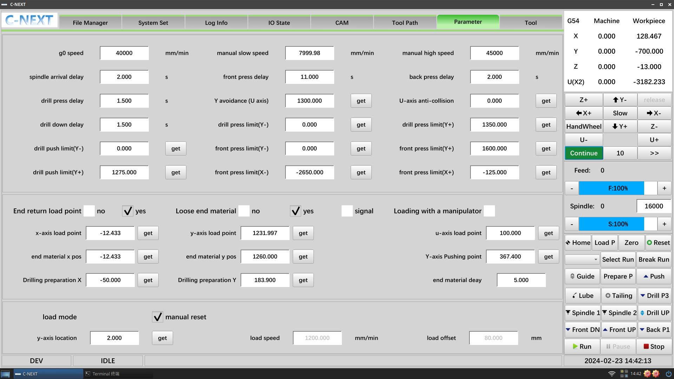

* **G0 speed**: programme empty running speed, unit mm/min;
* **Manual slow speed**: Continuous mode low speed operation in mm/min;
* **Manual High Speed**: Continuous mode high speed operation in mm/min;
* **spindle arrival delay**: spindle start delay processing, unit s;
* **front press delay**: delay time after the output of pre-pressing material cylinder, unit s;
* **back press delay**: Post-compression material cylinder output delay time, unit s;
* **drill press delay**: the time delay for the drilling and pressing cylinders to move into position;
* **Y avoidance (U axis):** Maximum travel during Y-axis avoidance;
* **U-axis anti-collision:** If the U-axis does not exceed the "**U-axis anti-collision**", the Y-axis travelling is unlimited; if the U-axis exceeds the "**U-axis anti-collision**", the Y-axis can only go to the "**Y avoidance (U axis)**" position;
* **drill down delay:** The time when the drill lift cylinder action is completed;
* **drill press limit(Y-):** Negative limit of Y-axis movement for normal downward pressure of the drill press cylinder.
* **drill press limit (Y+):** Positive limit of Y-axis movement for normal downward pressure of the drill press cylinder.
* **drill push limit(Y-): the** drilling top plate works normally and the Y-axis moves the negative limit.
* **drill push limit(Y+): The** drilling top plate is working normally and the Y-axis movement is positively limited.
* **front press limit (Y-): The** front pressure works normally and the Y-axis moves to the negative limit
* **front press limit (Y+): The** front pressure is working normally and the Y-axis movement is positively limited.
* **front press limit (X-): The** front pressure works normally and the X-axis moves negative limit.
* **front press limit (X+): The** front pressure is working normally and the X-axis movement is positively limited.
* **Positional parameters:**

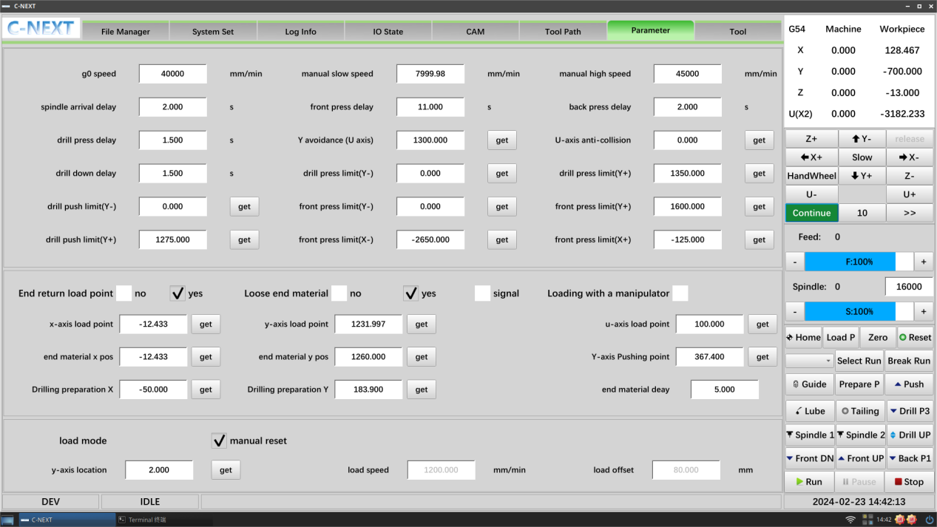

**End the meeting point (ticked):**

**(1) No, processing is completed and stops at the current position; (2) Yes, processing is completed and returns to the loading point;**

**Loose end manterial (ticked):**

**(1) No, end no loose ends; (2) Yes, end loose ends; (3) Signal, end wait to continue running signal loose ends**

* **X-axis load point:** The programme activates the safety bit of the X-run, in conjunction with the gantry loading, to avoid touching;
* **Y-axis load point:** The programme activates the safety bit of the Y-run to match the gantry loading to avoid collision;
* **U-axis load point:** Side push cylinder output position after Y-axis moves into place;
* **end material X pos:** After all whole material movements have been travelled, Y moves into position and outputs the press wheel 1/2;
* **end material Y pos:** exceeding the set value requires resetting the pressure wheel cylinder to avoid collision, illustration (1-8)
* **end material delay:** Loose end material delayed back to fixed point;
* **Drilling preparation X:** When the drilling programme is executed, the X-axis runs to the ready position to start machining;
* **Drilling preparation Y:** When the drilling programme is executed, the X-axis runs to the ready position to start machining;
* **Y-axis location:** the marking position where the rapid feed arrives and starts to feed the material at the feed speed at this position;
* **Load speed:** The speed at which the feed shaft moves;
* **Load offset:** Compensation value for feeding;

## 1.2 Machining trajectories

After the system is switched on, the machining track interface is opened by default. The automatic interface, as shown in the figure below, is the intuitive observation interface after the CNC programme is run, containing the programme running information, graphic display window, programme display window, and so on.

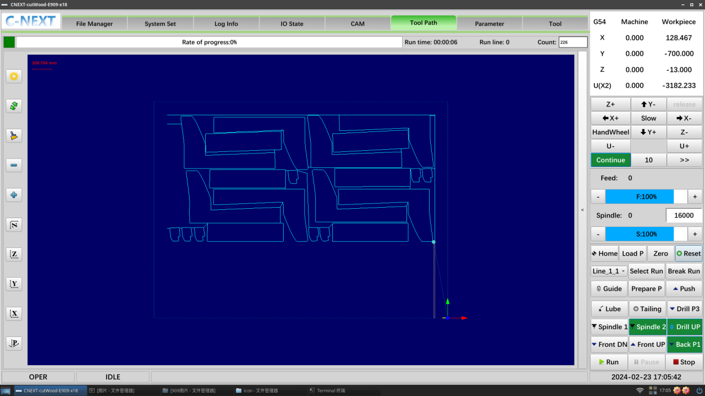

**(Real-time display of machining trajectories)**

### 1.2.1 Count Zero:

In the upper right corner of the machining trajectory page, there is a workpiece zero function, which facilitates the machining count, counting +1 for each completed machining.

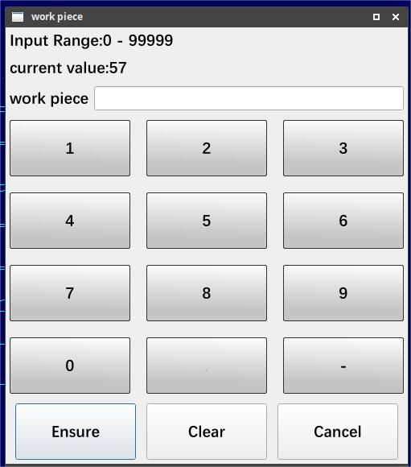

**(When the modification is complete, the number of modified pieces will be displayed in the information column below.)**

### 1.2.2 Breakpoint runs:

***(This function automatically records the breakpoint when executing the drilling programme and the line break when executing the opening programme.)***

Alarm stops may be encountered during operation

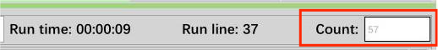

1. Find and click "Break Run" in the interface control bar.

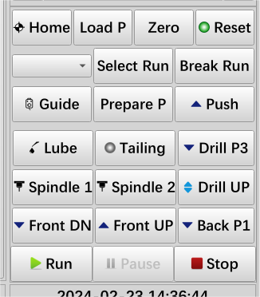

1. After you open the breakpoint run, it will automatically record the line number of the current breakpoint, click the breakpoint to run

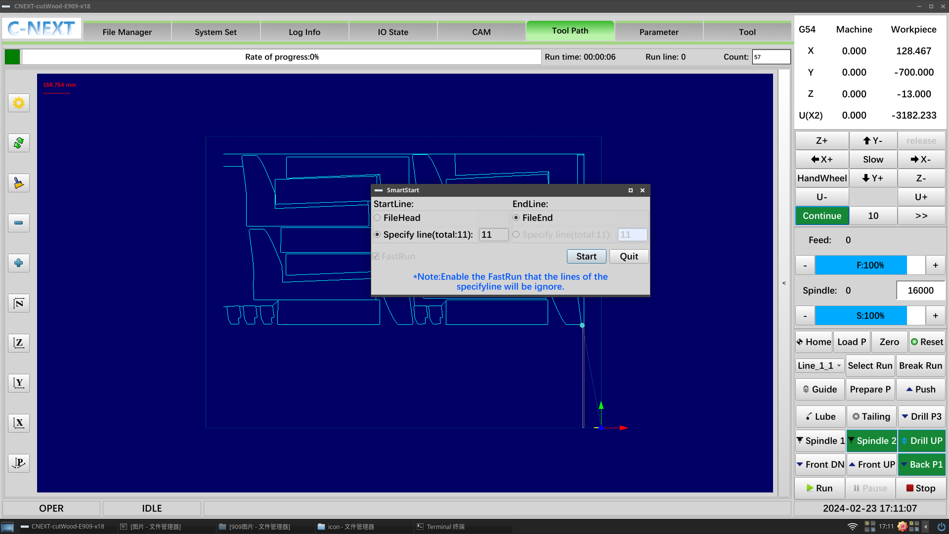

*(Line numbers of breakpoints are automatically recorded)*

### 1.2.3 Selection of rows for processing:

***(This function is only for the opening group)***

1. Find " Select Run" in the interface control bar.

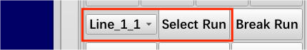

1. The drop-down list shows the different area trajectories that can be selected.

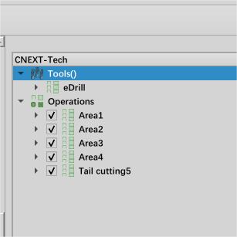 Area corresponding to CAM 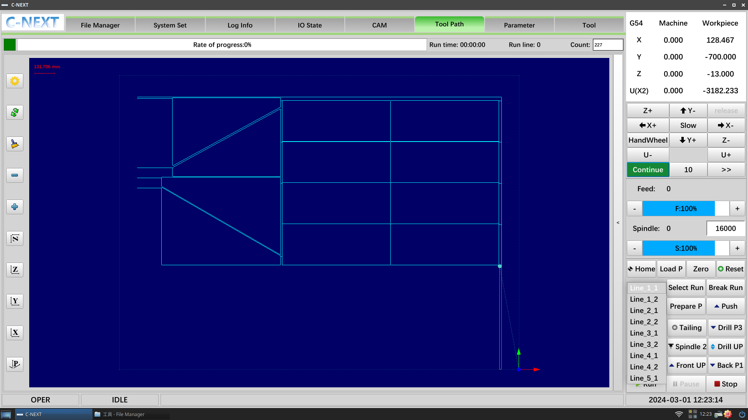

1. Select the corresponding line number, click the line processing will pop up the following prompt box, select "Yes" to open the line processing

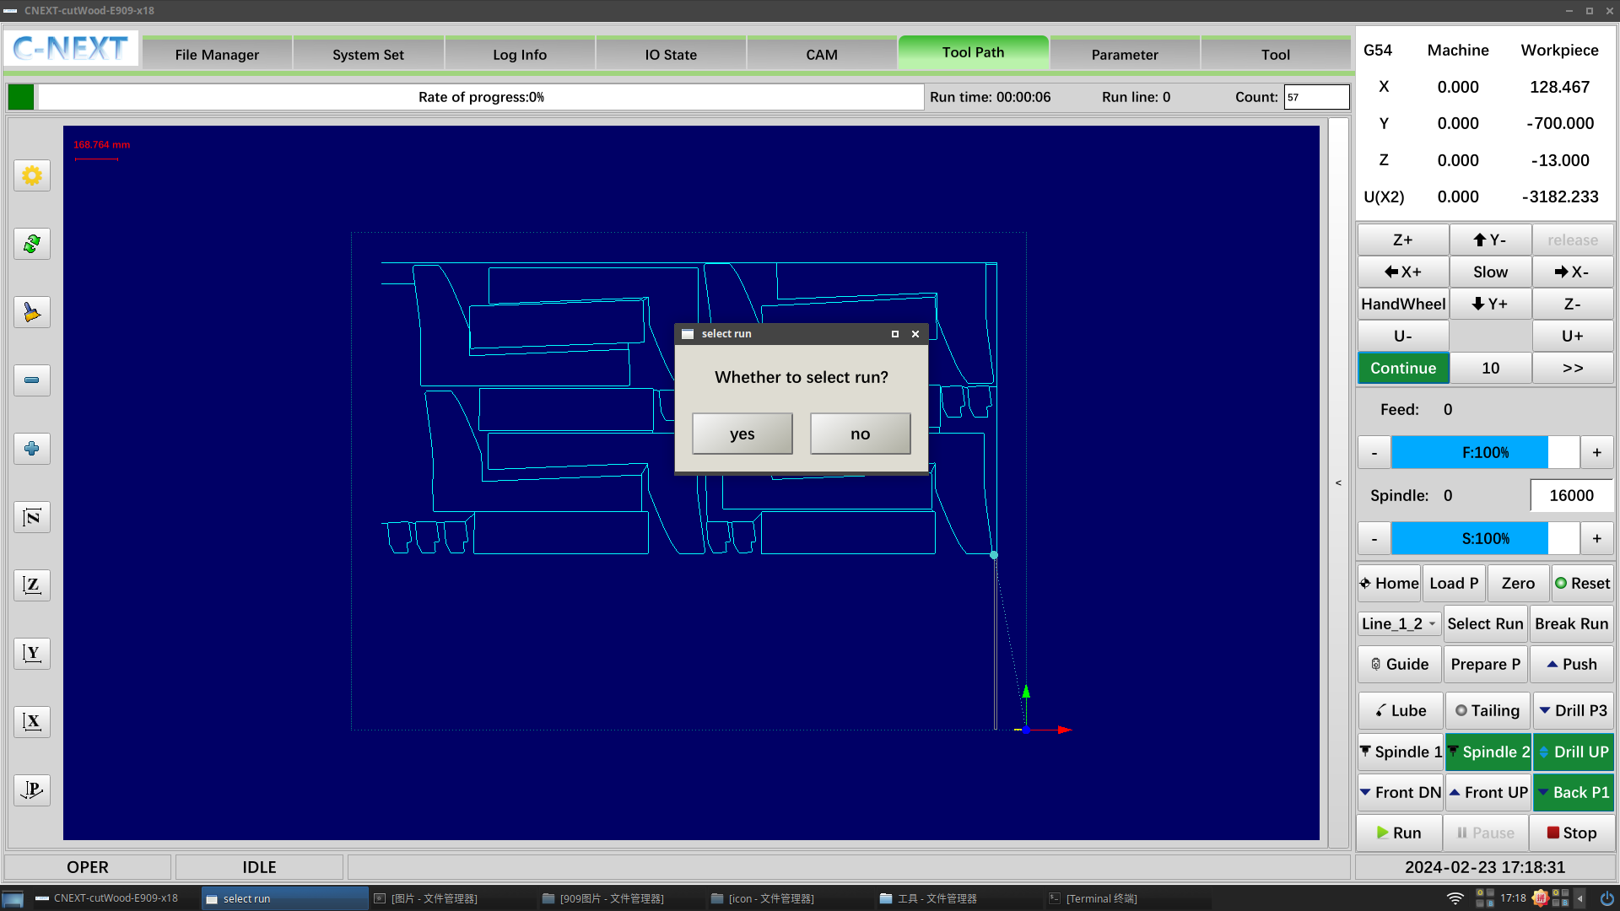

## 1.3 Tool magazine

Tool magazine page for easy viewing of current tool number, manual tool change, and modification of tool length and tool holder coordinates.

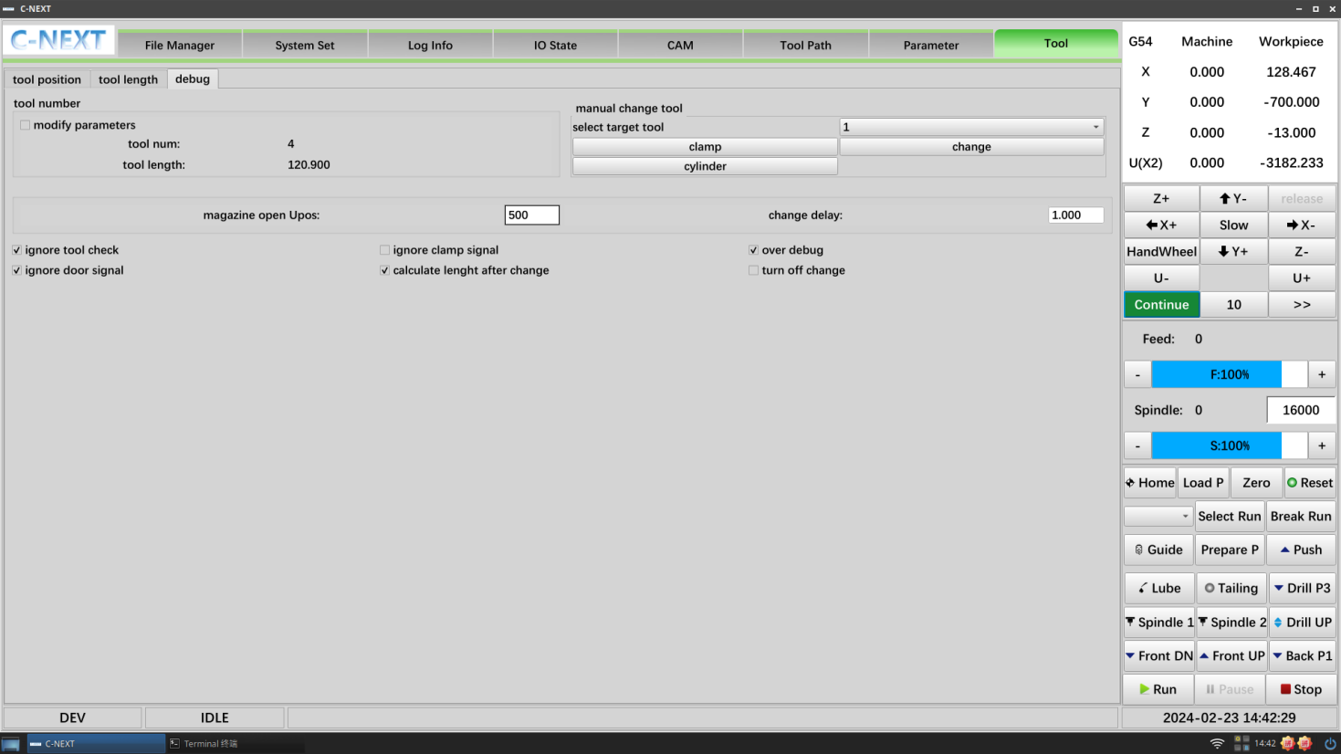

#### Cutting tool information

**Displays the current tool number and tool length data**

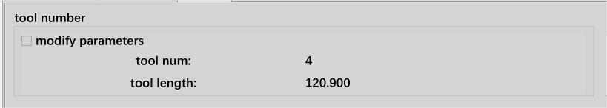

Modify parameter password: 0000

#### Manual tool change

1. Step 1: View the current knife number and confirm the selection of the target knife number



1. Step 2: Choose to confirm the execution of tool change action, choose direct setting, directly assign the target tool number to the current tool number.

(Directly set password: 0000)

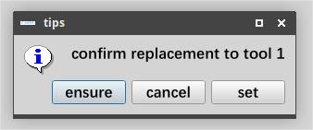

1. Step 3: Determine, execute the tool change action, tool change is complete, the tool number is consistent

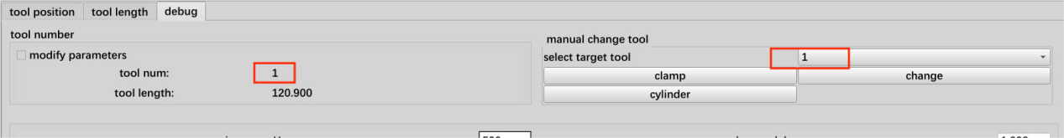

#### Tool length

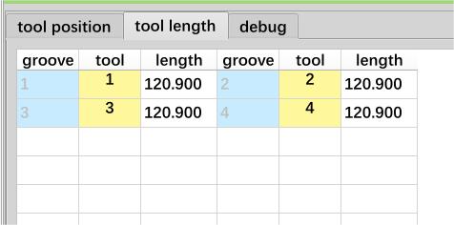

#### Tool holder coordinates

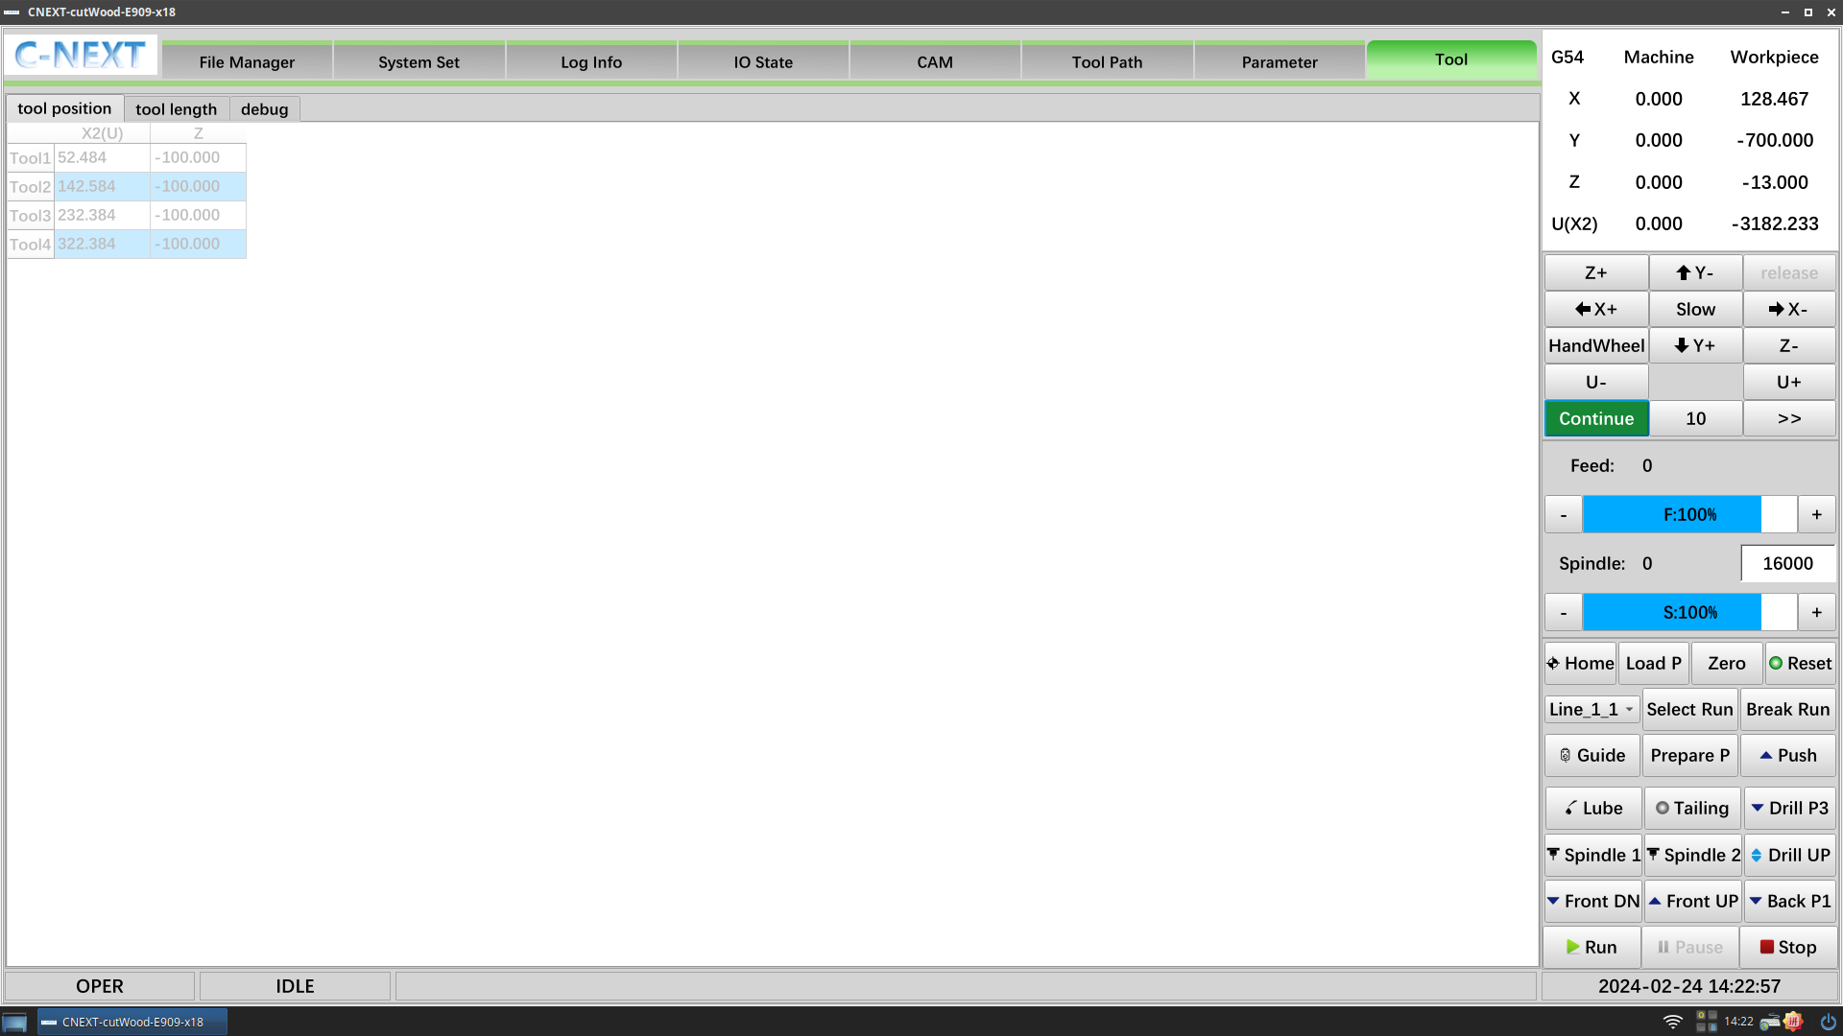

*(Unchecked debugging modification parameter status is read-only, modification needs to be checked modification parameter)*

## 1.4CAM

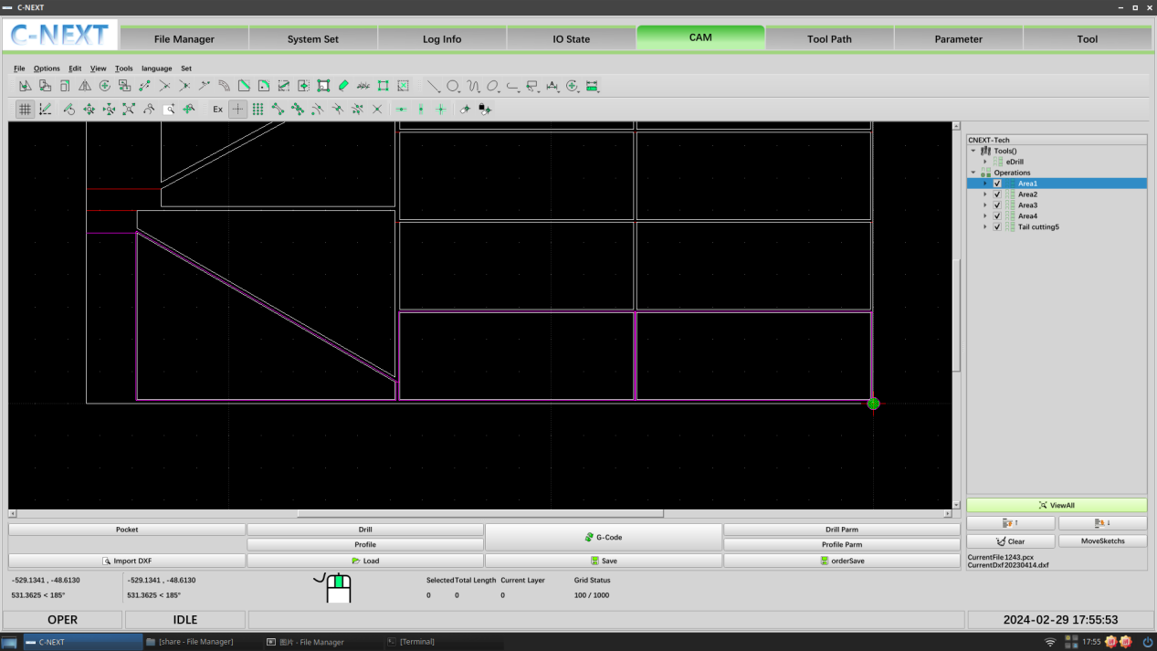

### 1.4.1 Parameter setting steps:

Before generating a round hole, you need to set the tool parameters

1. Step 1: New/Edit Tool

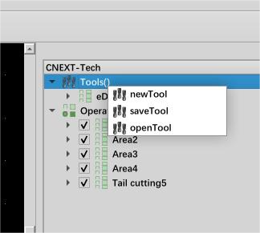

1. Step 2: Set the tool parameters:

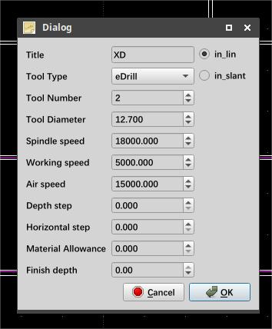 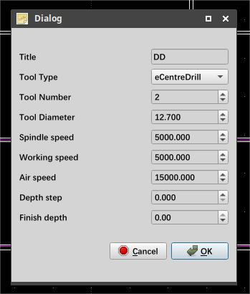

Title: Tool naming;

Tool Type: centre drills;

Tool Number: tool number, default 1;

Tool Diameter: Tool Diameter;

Spindle speed:Rotation speed of the tool;

Working speed:Machining speed of the tool;

Air speed:Speed of air travel;

Depth step:Distance of one machining in vertical direction;

Horizontal step:Distance to be processed horizontally at one time;

Material Allowance:Remaining unprocessed portion of material;

Finish depth:End this processing depth;

1. Step 3: Round hole parameters/opening parameters

* **Round hole parameters:**

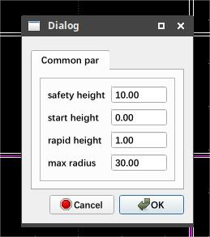

* Safe height: Safe height of Z-axis movement after drilling
* Starting height: from safe height to starting height;
* Positioning height: the amount of undercutting has been calculated from the positioning height, e.g. positioning height 5, undercut even -10, Z5->Z-5.
* Max radius: perforation identification parameter, when the radius of the circle exceeds the change value is not recognised as perforation;
* **Opening parameters.**

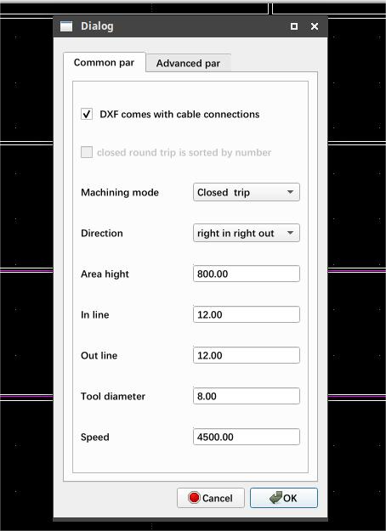 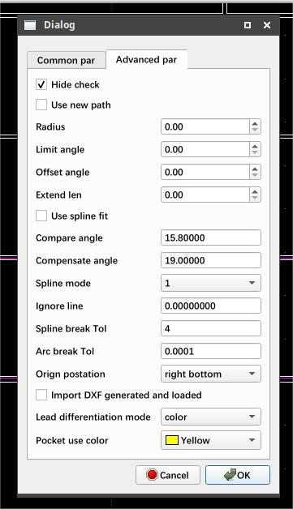

*Advanced parameters: 0000 (not modified by the operator)*

Basic Parameters**.**

Whether DXF drawings come with a lead: drawings come with a lead is required, if the drawings do not have a lead is also checked will print a reminder;

Closed round trip sorted by number: This option needs to be ticked if the processing mode is closed round trip;

Processing mode: closed round trip;

Directions: Right in, right out;

Area High Value: This parameter is for example within 570 of the graphic length of the Y-axis, optimised for the typographic X-direction;

Introductory line: the length of the tool retreat when feeding the tool, unit mm;

Lead wire: the extra length of the tool travelling when retracting the tool, unit mm;

Tool diameter: diameter of the opening tool;

Speed: Machining speed;

### 1.4.2 Importing DXF

Click on the Import dxf button to open the target drawing;

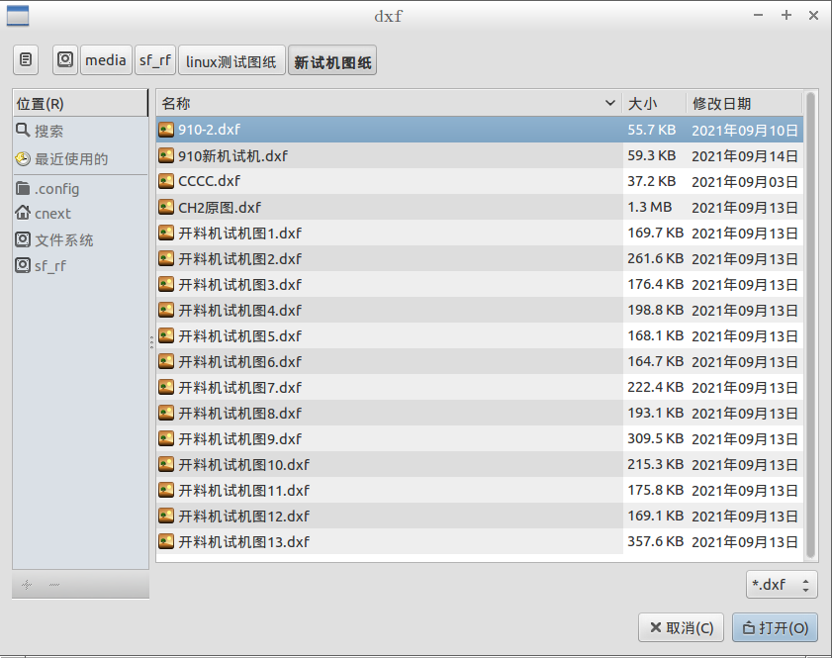

### 1.4.3 Generation programme

**After the drawing is imported, the origin is set by default with the lower right corner of the drawing as the reference**, if you need to change the origin, please click the border of the drawing and then select the "Change Origin" button in the lower right corner;

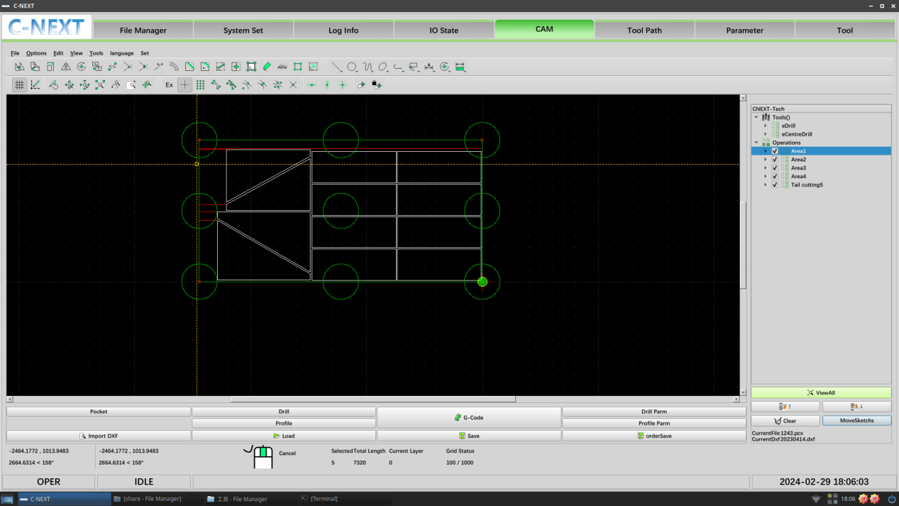

1. **Selected trenching**

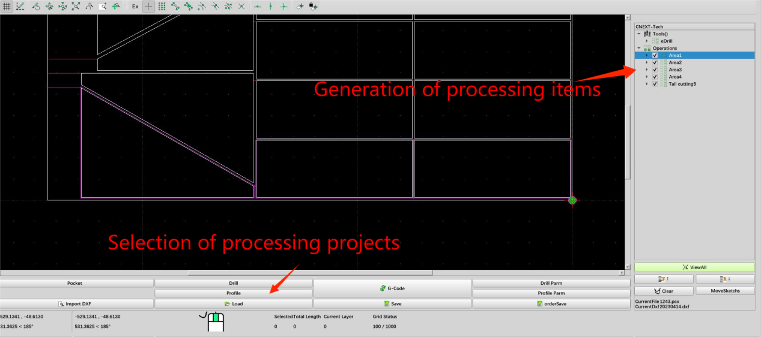

1. **Generate G-code**



**3. Load to the system to complete the pop-up window appears that the code has been loaded, CNC can be run!**

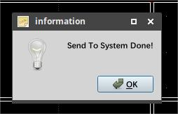

### 1.4.4 Saving loads

With the function of saving and loading scheme: product replacement can call the scheme at any time, more convenient. Save the contents as .pcx file including: drawing, path, parameters, etc;

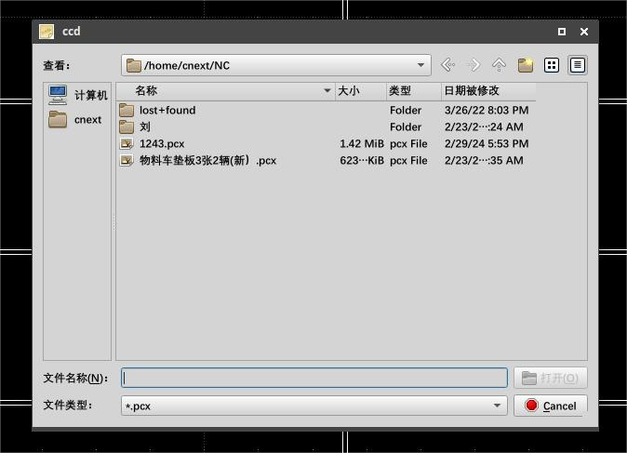

(loading works)

## 1.5 I/O Status

The IO Status screen displays information about the list of input and output ports of the IO board and monitors the status of each IO as shown below. Click <Input > and <Output > to view the input and output port information.

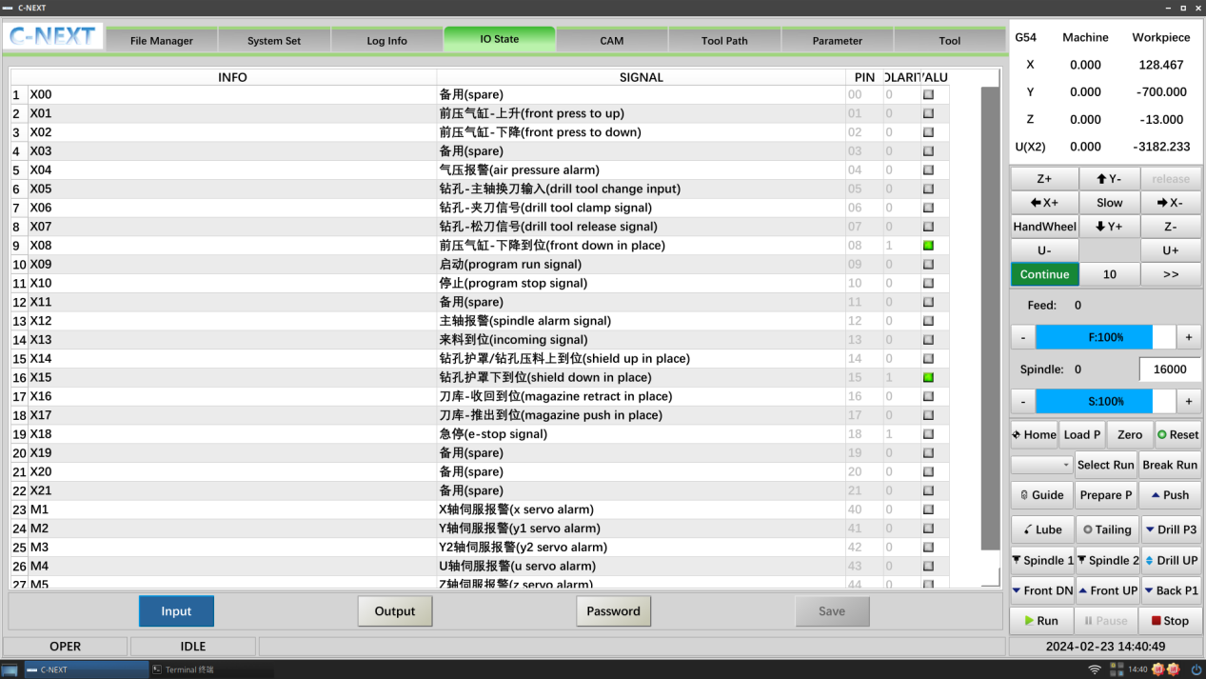

Perform real-time IO monitoring and can modify IO pins and polarity. Signal value green means there is a signal:



To modify the pin and polarity, you need to enter the debug password first: 0000

Then click on the corresponding pin or polarity of the list and operate as follows:

### 1.5.1 Modifying pins

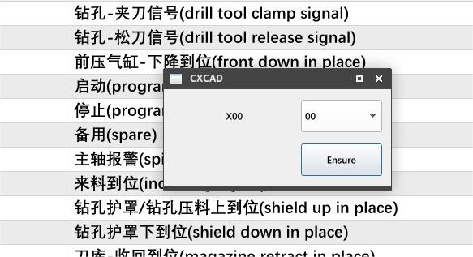

Figure 1-24 Modifying Pins

Click the number to select the target pin, confirm the replacement, and click OK; complete a pin replacement.

### 1.5.2 Modifying polarity

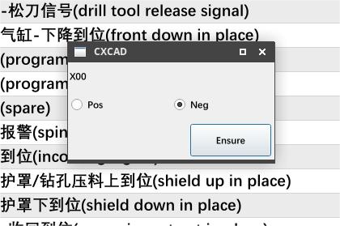

Figure 1-25 Modifying Polarity

Select Positive or Negative and click OK; complete a polarity modification.

## 1.6 Log messages

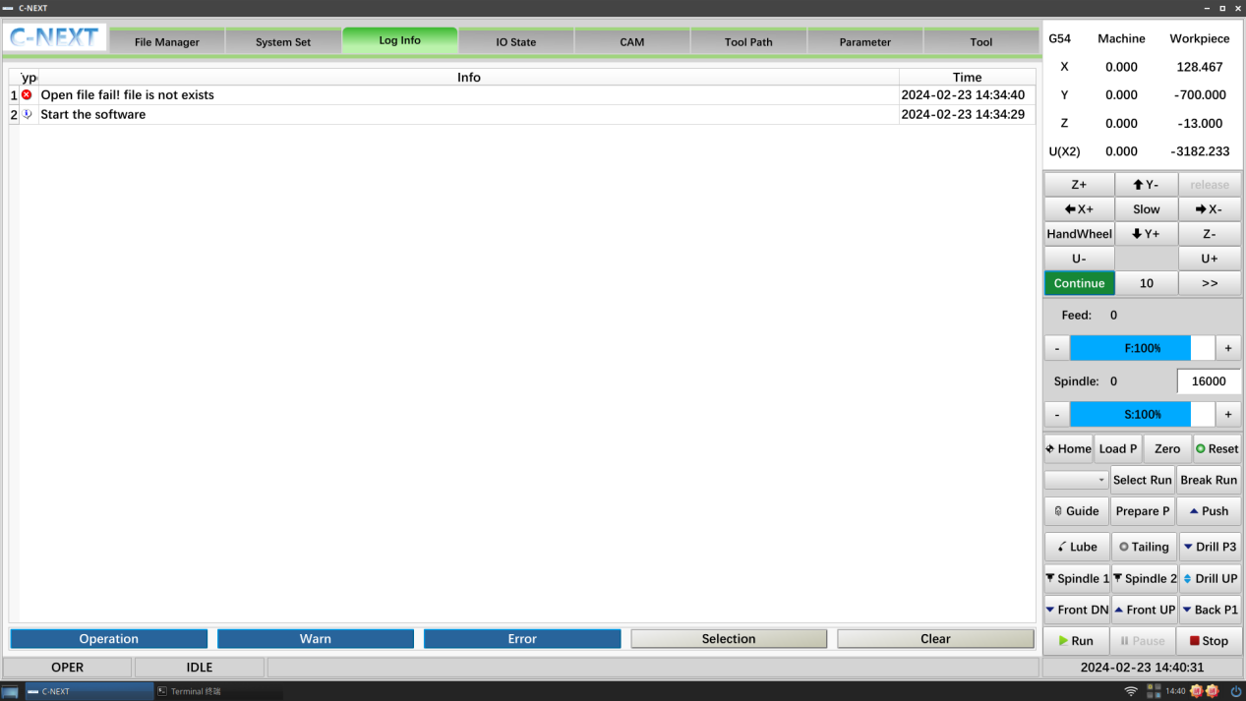

Displays operation information, warning messages, and error messages since power-on for easy error checking.

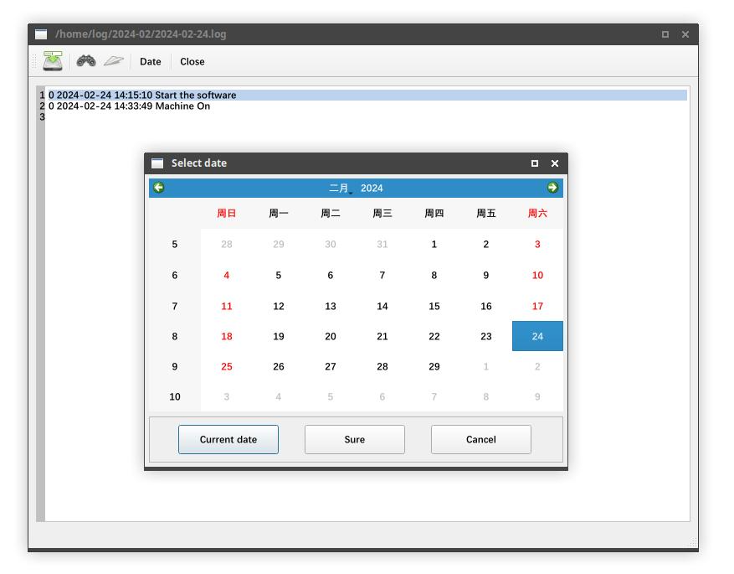

Figure 1-27 Selecting a Date

You can select the date to display past information.

## 1.7 System set

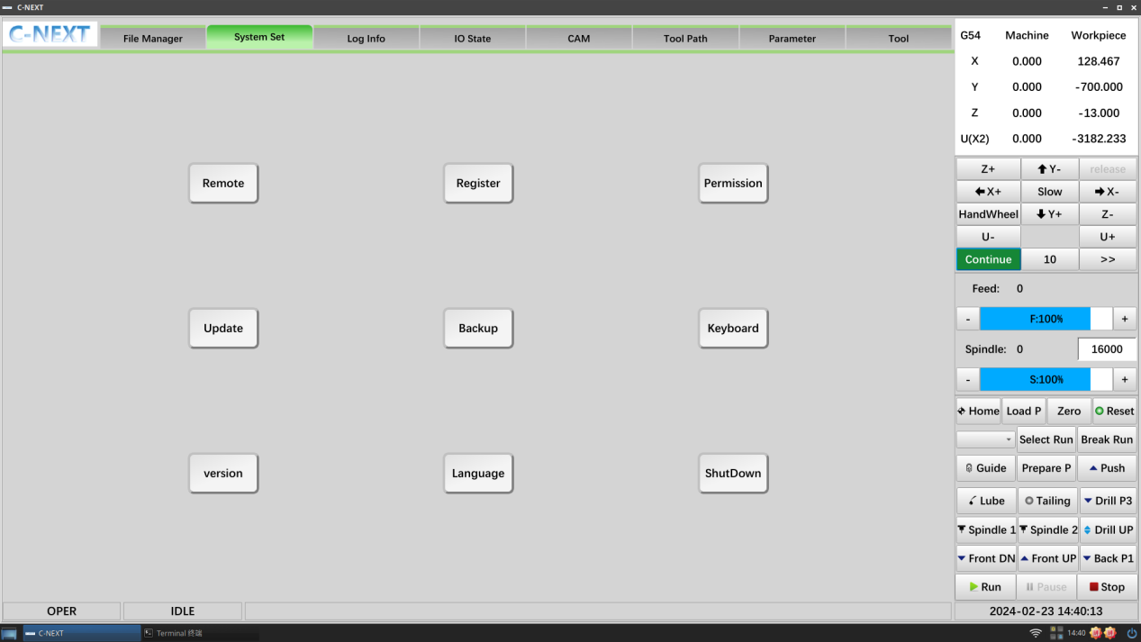

Some system tools.

### 1.7.1 Remote control

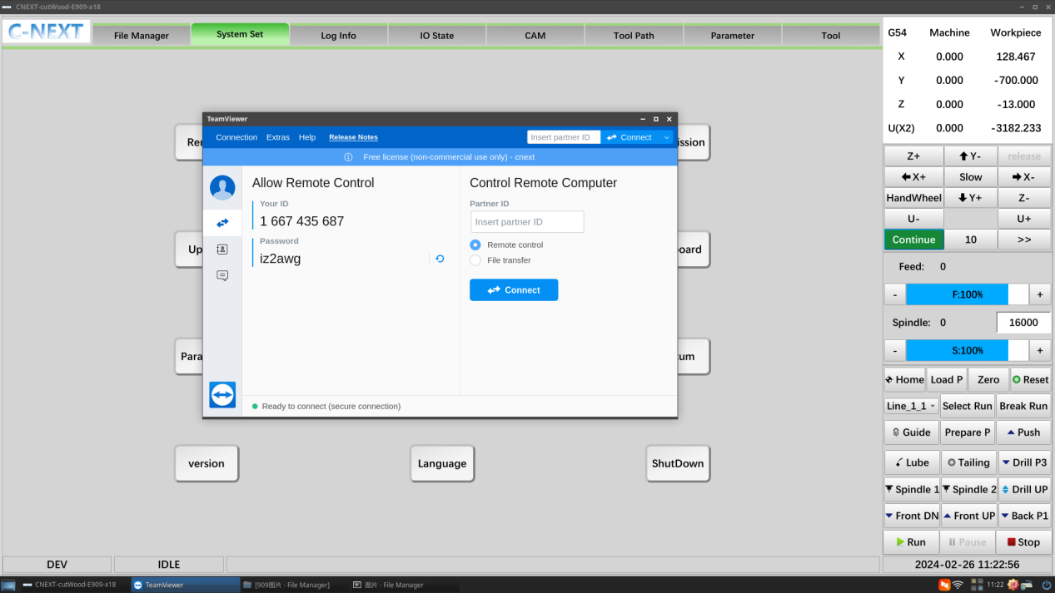

Figure 1-29 Remote Control

Remote control requires an internet connection, click the <Remote> button, open TeamViewer, take a picture of the screen shown above and send it to the vendor, who can control the system remotely with an ID and password.

### 1.7.2 Software registration

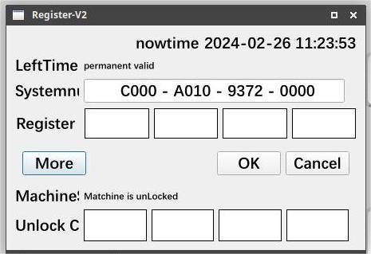

Figure 1-30 Software Registration

View the system number, registration status, and mechanical status.

When it appears that the software is not authorised or the registration time has expired, contact the manufacturer.

### 1.7.3 Operational authority

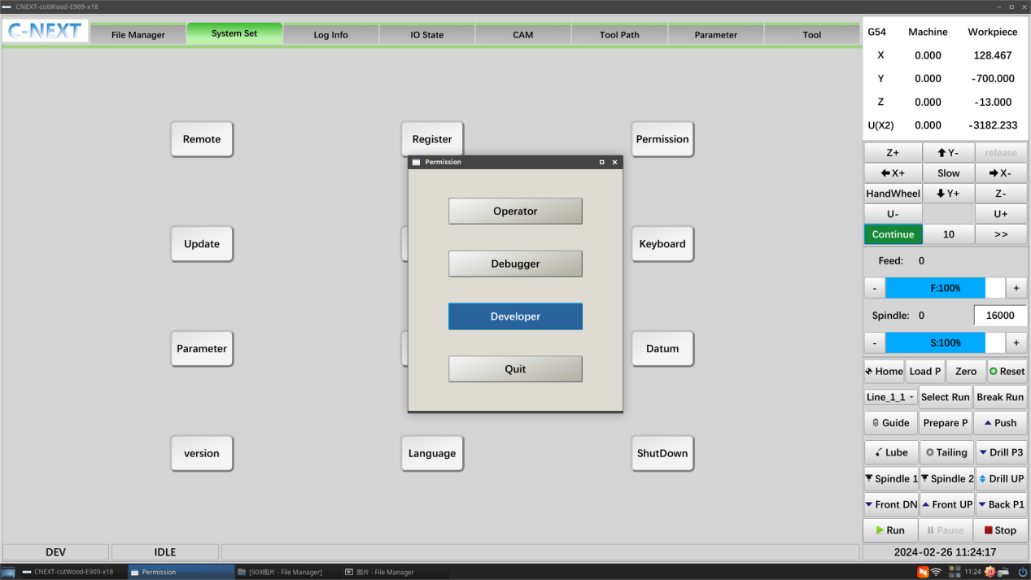

Figure 1-31 Operating Privileges

The system has 3 levels of authority:

1. Operator: Operator privileges do not require a password; the operator can perform some running operations;
2. Debugger: debugging password 0000; the debugger can carry out process parameters (section 1.1.7) and set the zero point of the workpiece (section 1.1.5);
3. Developer: Development code 4321; the developer can set the mechanical zero point (section 1.1.4), modify the system parameters (section 1.9.7), and the servo parameters (section 1.9.8).

### 1.7.4 Software updates

Figure 1-32 Software Upgrade

Update the software version;

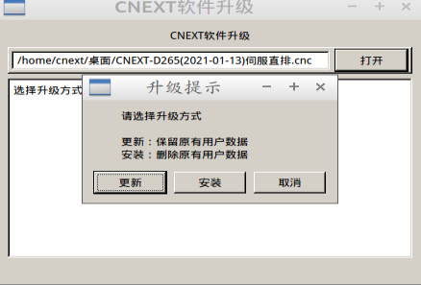

Update: Retain the original user data, recommended for debugged machines, for software upgrades;

Installation: Deletes the original user data, usually used by a new machine to install a backup package or to restore a backup package; please use caution when installing.

### 1.7.5 Generating backups

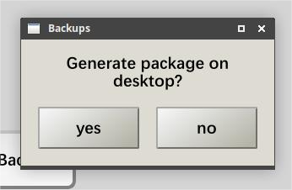

Figure 1-33 Generating an Installation Package

Generate an installation package in .cnc format in the path of your desktop for packing backups.

### 1.7.6 Soft keyboard

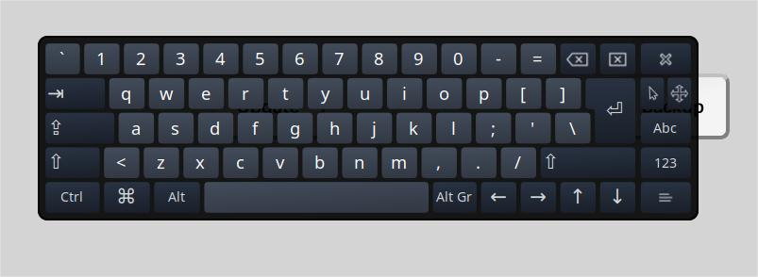

Figure 1-34 Soft Keyboard

The system comes with a software disc.

### 1.7.7 System parameters

Modify the built-in parameters of the system:

1. Operating parameters: Commonly used to modify manual travelling speeds, and mechanical fixed point positions;

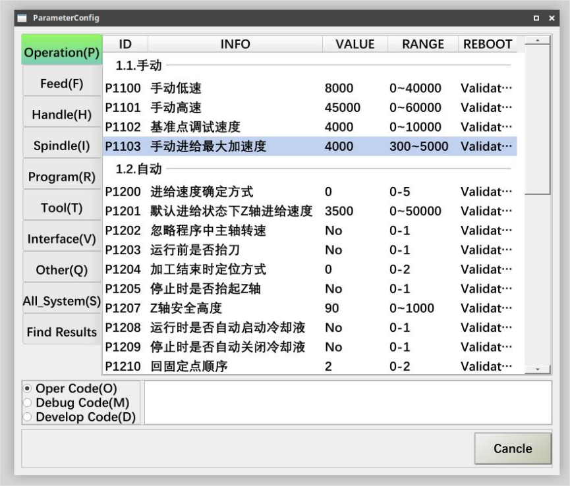

Figure 1-35 Operating Parameters

1. Feed Parameters: Sets parameters for the feed axes, axis direction, pulse equivalent, speed and acceleration, travel limits, etc;

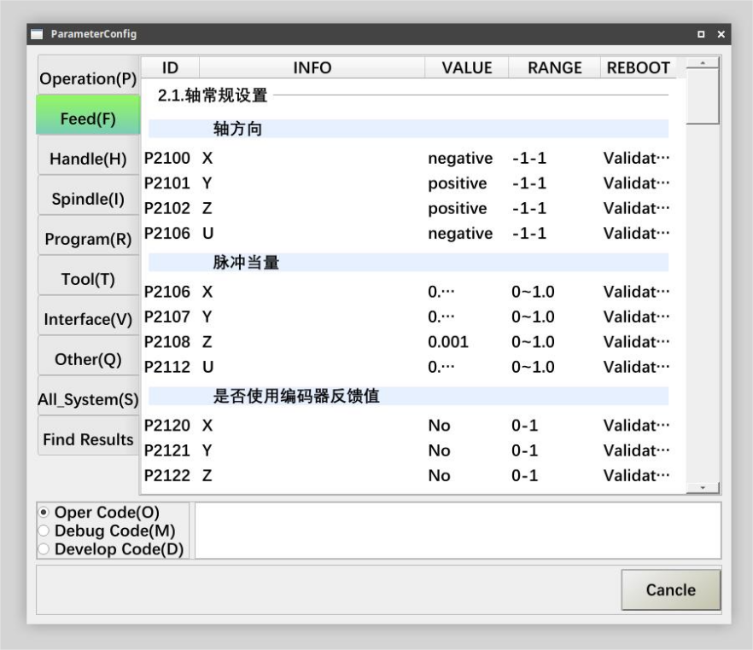

Figure 1-36 Feed Parameters

Spindle parameters: Setting spindle parameters so that the speed corresponds to the actual speed, as well as limiting the maximum speed;

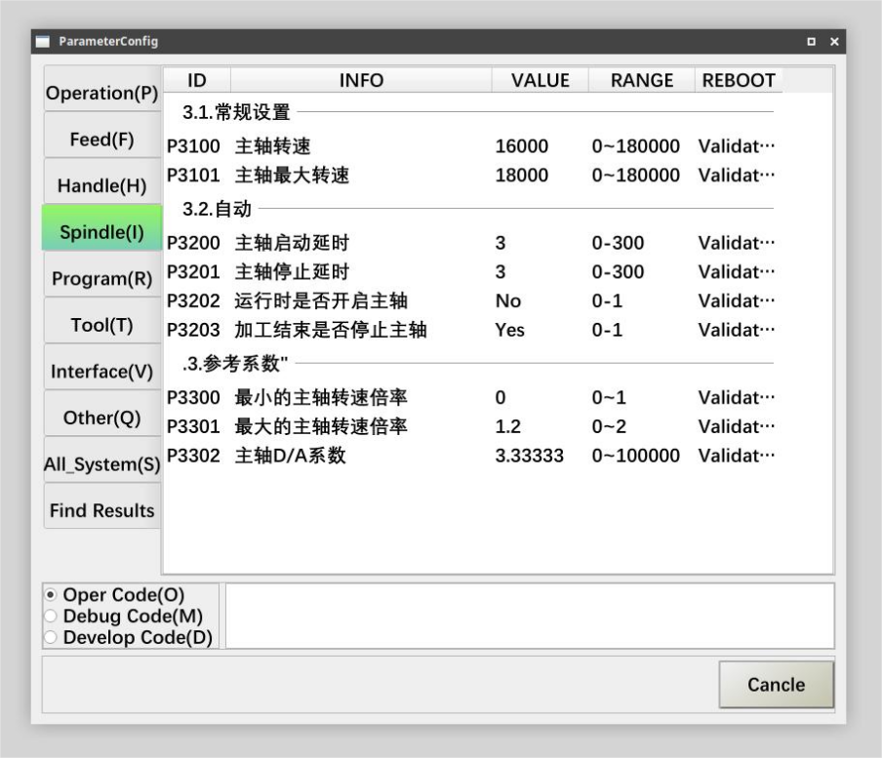

Figure 1-37 Spindle parameters

1. Handwheel Parameters: Modify handwheel related parameters;

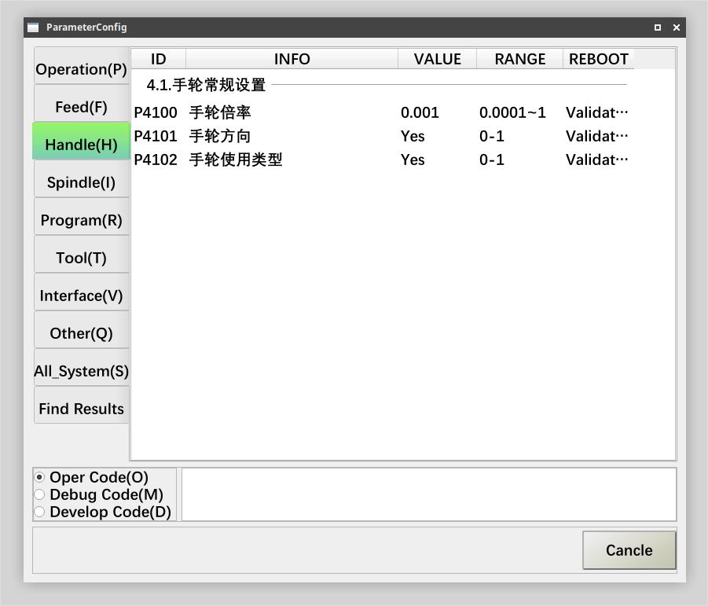

Figure 1-38 Handwheel Parameters

1. System parameters: Modification of parameters for communication, number of axes, connection order, etc;

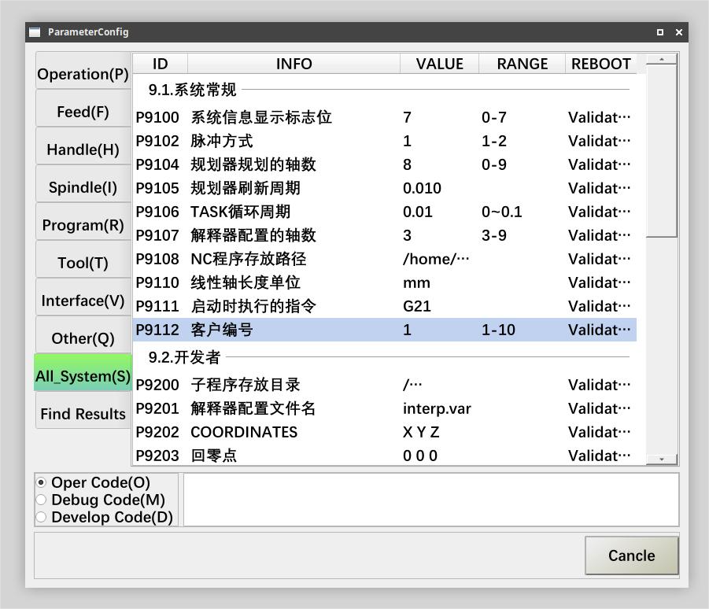

Figure 1-39 System Parameters

### 1.7.8 Servo parameters

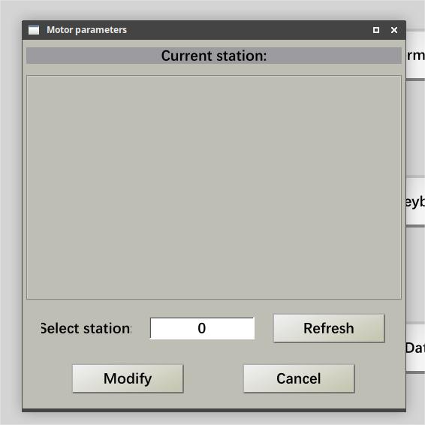

Figure 1-40 Motor Parameters

Station number: 0-100.

Refresh: Reads the motor parameters for the current station number;

Modify: Write the current parameter value to the current station number motor;

Tip: Click on the signal value input box of the corresponding parameter to modify the value.

In addition to this, you can contact the servo supplier to cooperate in debugging the servo parameters.

## 1.8 Document management

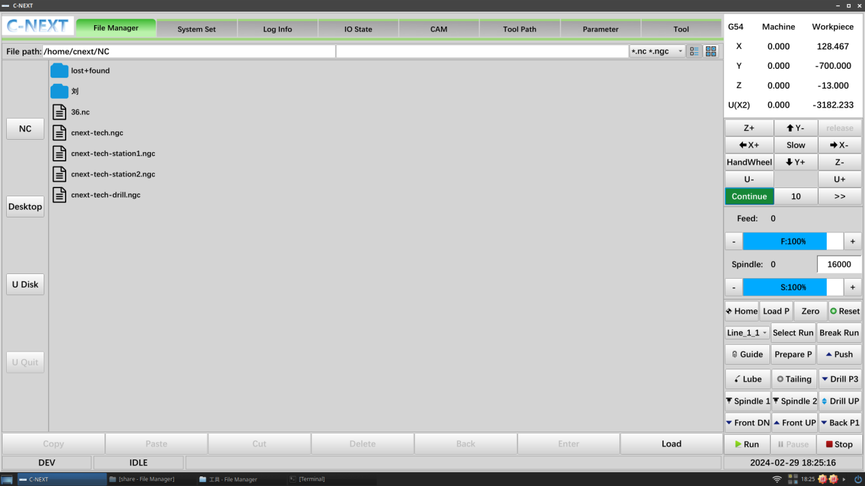

The file manager has 3 paths:

1. NC catalogue: Machining programs, machining drawings, and machining projects are recommended to be placed in this catalogue;
2. Desktop catalogue: the generated backup package is on the desktop;
3. USB stick: Insert a USB stick to access the USB stick path;

Load: is to load the selected NC programme to the system;

# 2 **Software Debugging**

## 2.1 Communication configuration

### 2.1.1 Communication parameters

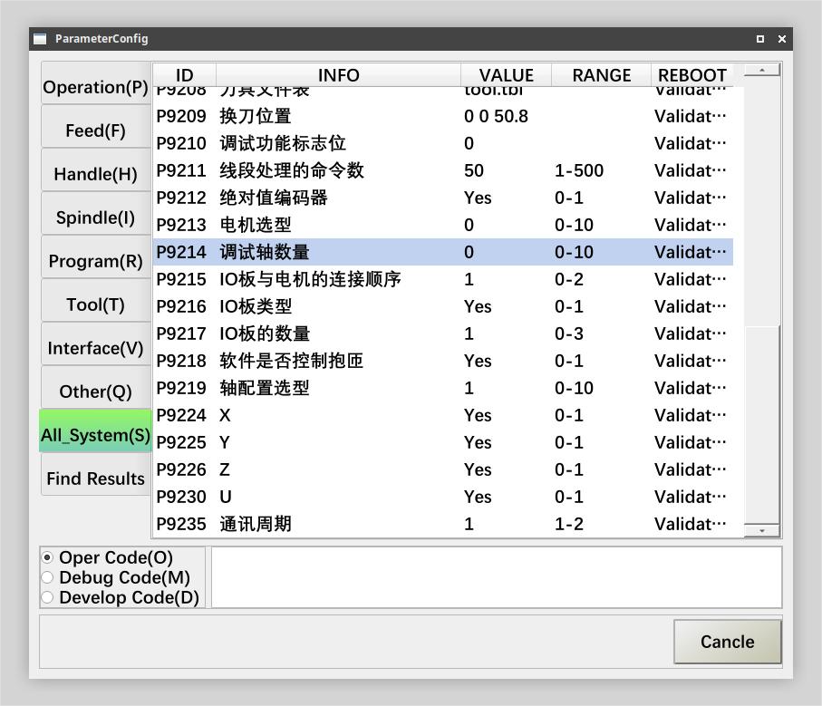

Figure 2-1 System Parameters

Confirmation of communication-related parameters first: section 1.9.7

P9214-Motor Selection; 0: Huichuan servo, 1: Tuco servo, 2: Delta servo, 3: Jiutong servo, 4: Heche servo.

P9215-Number of commissioning axes; actual number of drives to be connected.

P9216-IO board and motor connection order; 0 is to connect the motor first before connecting the IO board, 1 is to connect the IO board first before connecting the motor.

P9218-Number of IO boards; number of connected IO boards.

### 2.1.2 Connection order

The servo connection sequence for this configuration is to connect the system, the IO board and the servo via the network cable according to the set parameters.

### 2.1.3 Driver Enablement

Open the software, click the "Reset" button on the control bar, green indicates successful enablement; as follows

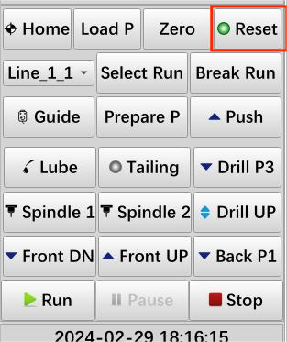

Figure 2-2 Enable State

If it is not possible to switch to the enabled state (the button is red), print the information according to the status bar, or consult the log messages to resolve the error first.

Note: Encoder feedback needs to be switched on for bus communication, as follows

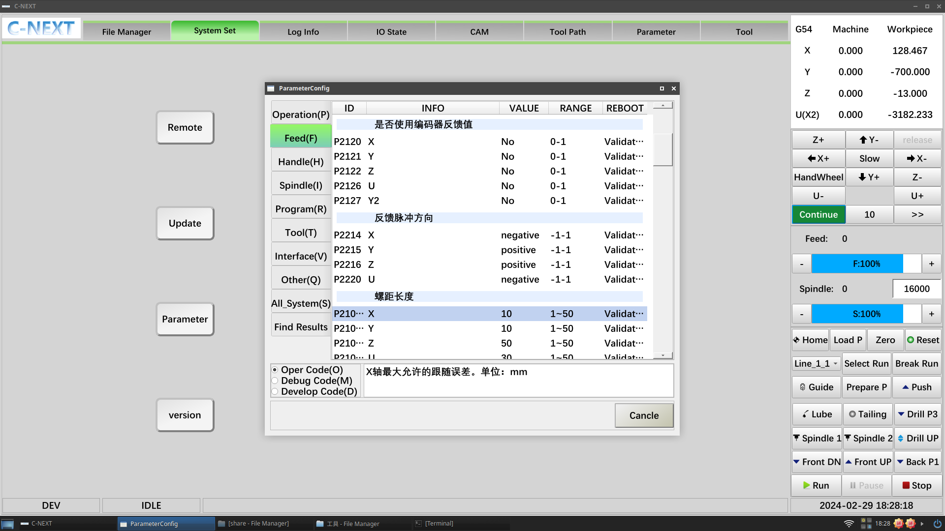

Figure 2-3 Encoder Feedback Value

### 2.1.4 Debugging axis parameters

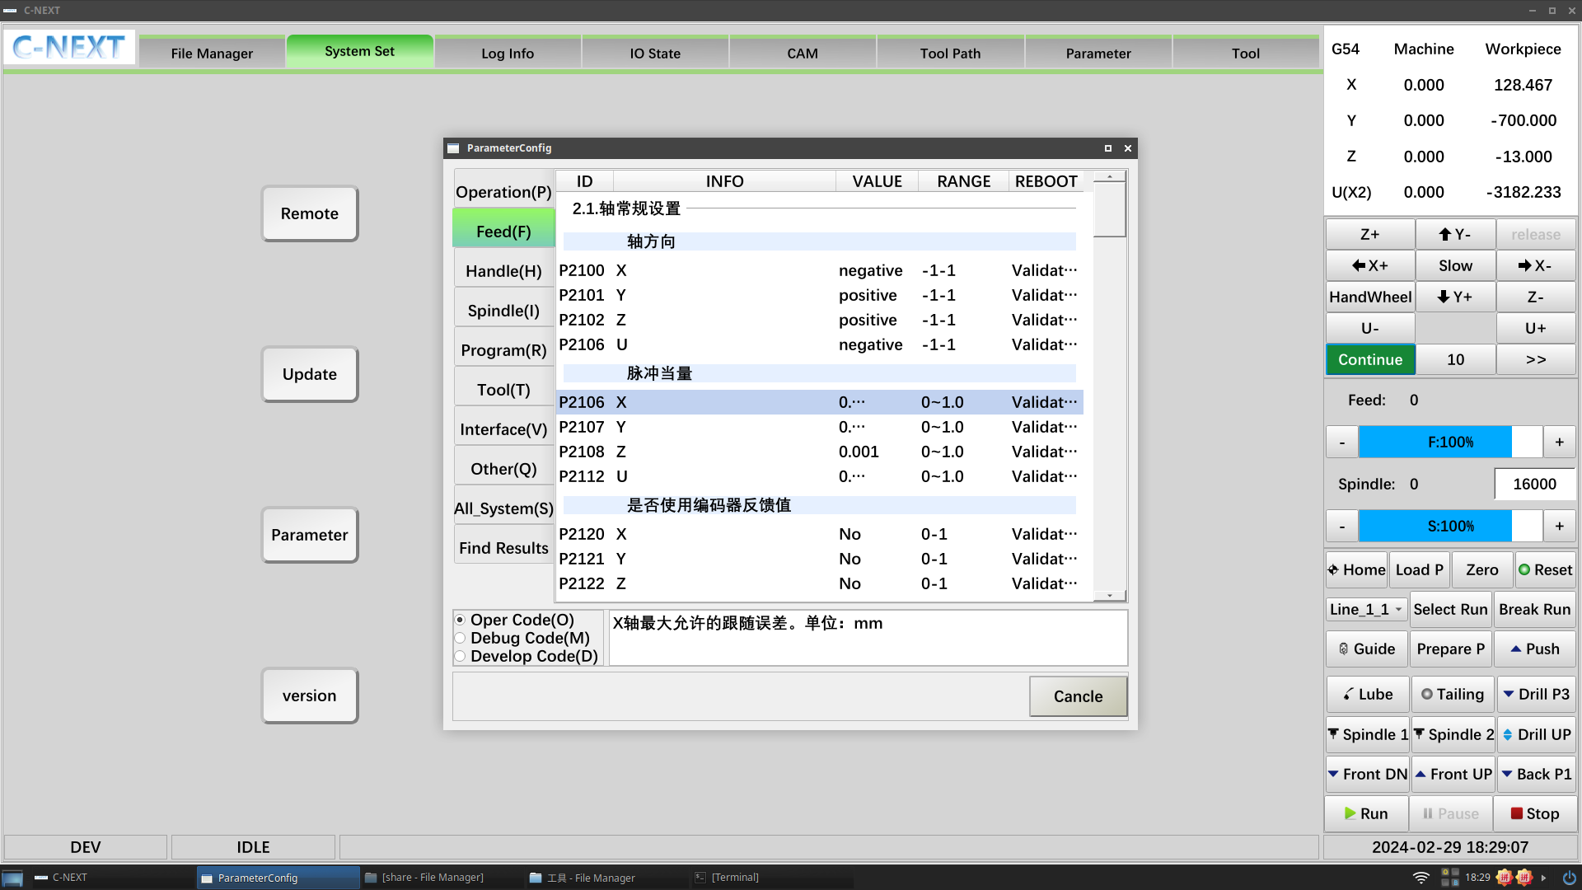

Figure 2-4 Feed parameters

## 2.2 Setting the pulse equivalent

Calculation of ball screws: Pitch / number of pulses for one revolution of the drive = pulse equivalent.

### 2.2.1 Determining axis orientation

Determine the axis orientation, following the right-handed Cartesian Cartesian coordinate system.2.2.2 Setting the mechanical zero point

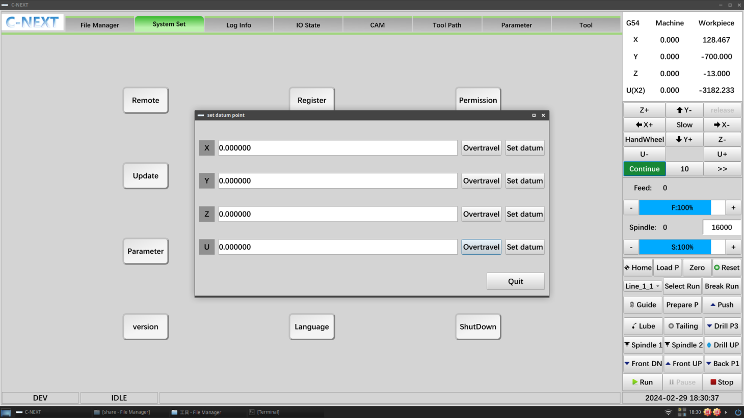

Figure 2-5 Mechanical Zero

Set the mechanical zero point, the setting method is according to section 1.1.4.

### 2.2.3 Determining machine travel

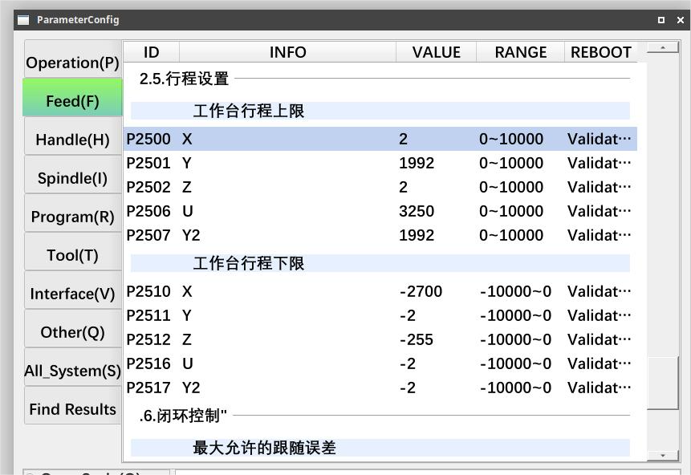

Figure 2-6 Mechanical Zero

If you are not sure of the trip, relax the limits and then move manually to determine the trip.

### 2.2.4 Debugging IO

IO port wiring definitions can be viewed in the Appendix.

Debugging is done through manual IO control (chapter 1.1.6), with IO monitoring (chapter 1.4 Machine status) and actual conditions.

### 2.2.5 Setting process parameters

According to section 1.1.7, set the X/Y position of the press material for each channel, as well as some delay times.

### 2.2.6 Setting the workpiece zero point

Refer to section 1.1.5 for setting the workpiece zero point.

# 3 **Quick start**

## 3.1 Establishment of communications

After the software is opened, confirm that the software and the servo driver have established communication, click on the "reset" button, the communication has been established for the reset button state is green: Figure

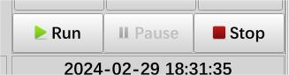

Figure 3-1 Enable State

If it is not possible to switch to the enabled state (the button is red), print the information according to the status bar, or consult the log messages to resolve the error first.

## 3.2 Loading procedures

The code is generated and loaded into the appropriate channel by means of a CAM operation.

Refer to section 1.4 for detailed operations.

## 3.3 Run processing

The programme generated from the CAM is loaded into the system; switch back to the automatic interface and click Run for the corresponding channel.

Try to use the handwheel guide for the first run for safe operation.